**Unearthing**

**the environmental**

**Impact on human activity:**

**a global co2 emission analysis.**

**1. INTRODUCTION**

**1.1 OVERVIEW**

Global warming is one of the biggest challenges currently being faced by the human race, although correlation is not causation, a likely cause of global warming is due to increased atmospheric carbon dioxide from human activities. CO2 Emission refers to the Carbon Dioxide emitted throughout the world. For this analysis we will be focusing on CO2 Emissions and its effect on the world we live in as well as some key factors and stats that may play a role in the emission of CO2 globally. Fossil fuel use is the primary source of CO2. The data throws light onto how much fossil fuels are burnt, per year per nation, which amounts to an increase in CO2 every year. This will help researchers and environment experts to predict global warming. So countries should set a goal to decrease this amount yearly. Analysing Global Co2 Emission across countries from 1975 to 2020. This dataset contains a record of Co2 Emission by each Country and Region of Earth, here we are going to analyse and visualise Country wise, Region wise and Overall Co2 Emission on Earth. Carbon dioxide (CO2) is released into Earth’s atmosphere mostly by the burning of carbon-containing fuels and the decay of wood and other plant matter. Under all conditions found naturally on Earth, CO2 is an invisible, odorless gas. It is removed from the atmosphere mostly by plants, which extract carbon from CO2 to build their tissues, and by the oceans, in which CO2 dissolves. Because CO2 is opaque to [infrared radiation](https://www.encyclopedia.com/science-and-technology/physics/physics/infrared-radiation) (the electromagnetic waves emitted by warm objects) in the atmosphere, it acts as a blanket to slow the loss of heat from Earth into space. Although other gases are also causing Earth’s climate to warm, CO2 alone is responsible for about three-fourths of [global warming](https://www.encyclopedia.com/science-and-technology/biology-and-genetics/environmental-studies/global-warming). The amount of CO2 in the atmosphere has increased greatly since human beings began burning large amounts of coal and petroleum in the nineteenth century. In more recent times, this source of CO2 emissions has increased rapidly, while destruction of forests has also become a major source of CO2. Atmospheric concentrations of several other gases, including methane (CH4) and [nitrous oxide](https://www.encyclopedia.com/science-and-technology/chemistry/compounds-and-elements/nitrous-oxide) (N2O), have also been increased recently by human activities and are contributing to greenhouse warming of the planet. Global warming is one of the biggest challenges currently being faced by the human race, although correlation is not causation, a likely cause of global warming is due to increased atmospheric carbon dioxide from human activities. CO2 Emission refers to the Carbon Dioxide emitted throughout the world. For this analysis we will be focusing on CO2 Emissions and its effect on the world we live in as well as some key factors and stats that may play a role in the emission of CO2 globally.

**1.2 PURPOSE**

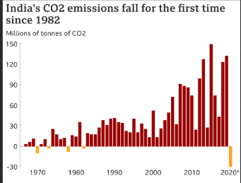

Though carbon dioxide is present in very small proportion (0.03%) in the atmosphere, it performs very important functions as mentioned below:

1. Carbon dioxide in the atmosphere does not absorb the incoming visible radiations coming from the sun blocks the out going infrared radiations radiated by earth. By absorbing infrared radiations, the atmosphere gets heated. This is known as Green house Effect. The heated atmosphere keeps the earthworm. Thus carbon dioxide helps in keeping the earth warmer by blocking the infrared radiations.

2. The plants utilize carbon dioxide during the process of photosynthesis.

3. Ocean absorbs carbon dioxide from the atmosphere to form carbonate rocks.

**2. PROBLEM DEFINITION & DESIGN THINKING**

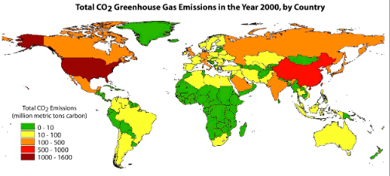**2.1 EMPATHY MAP**

**2.2 IDEATION & BRAINSTORMING MAP**

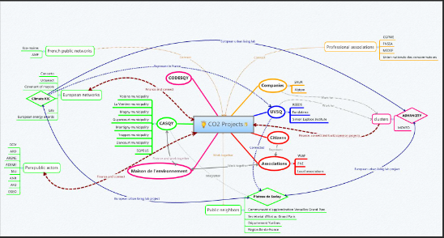



**Result:**





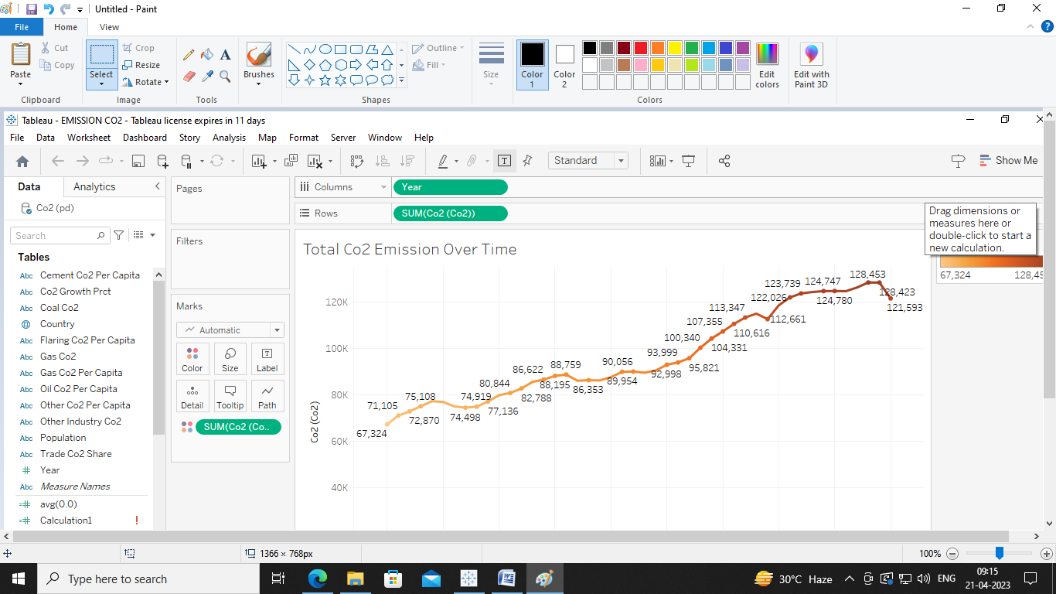

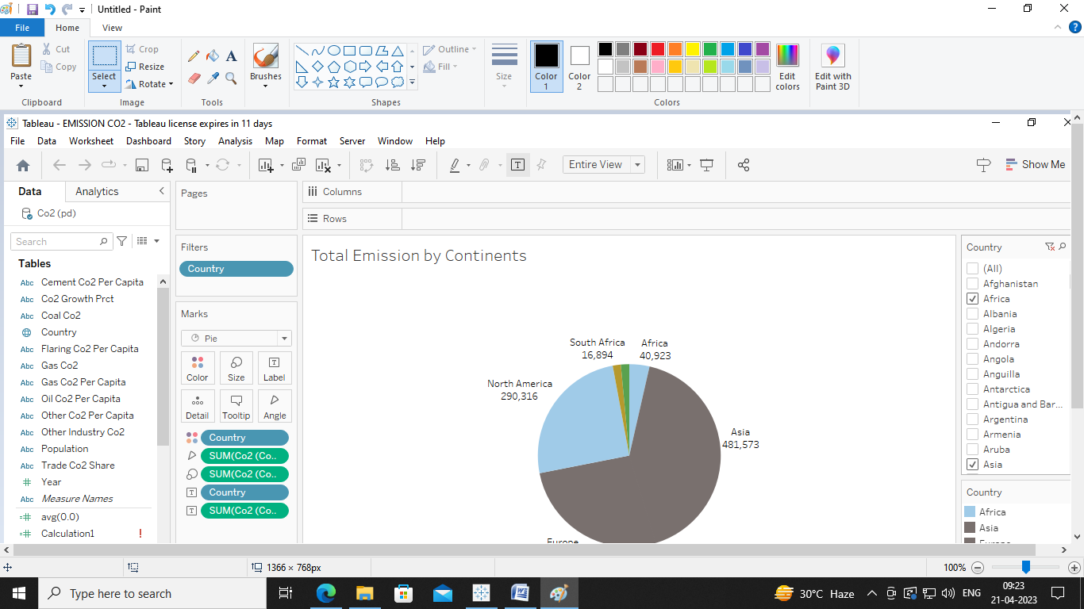

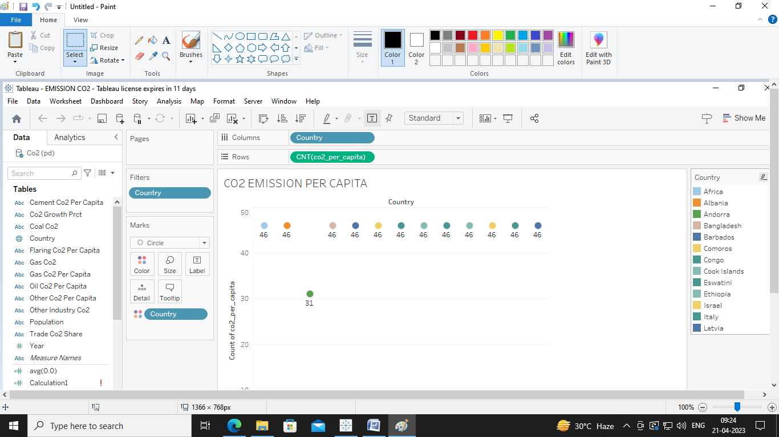

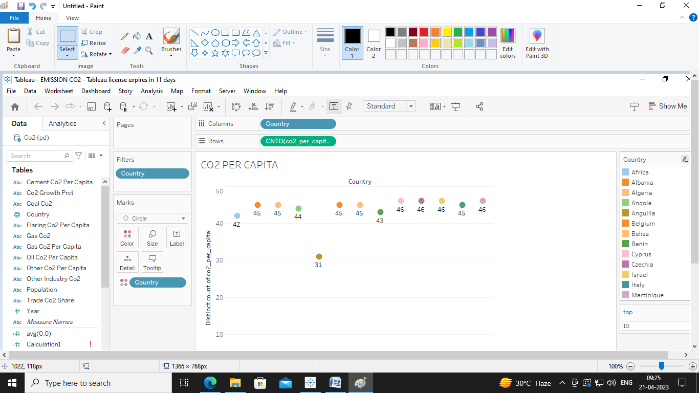

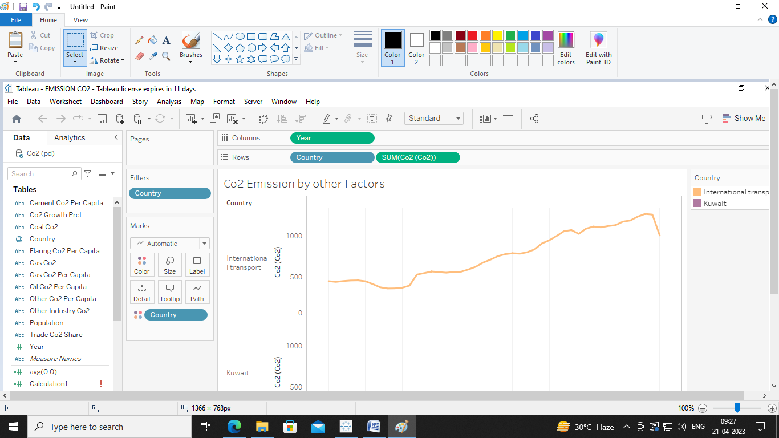

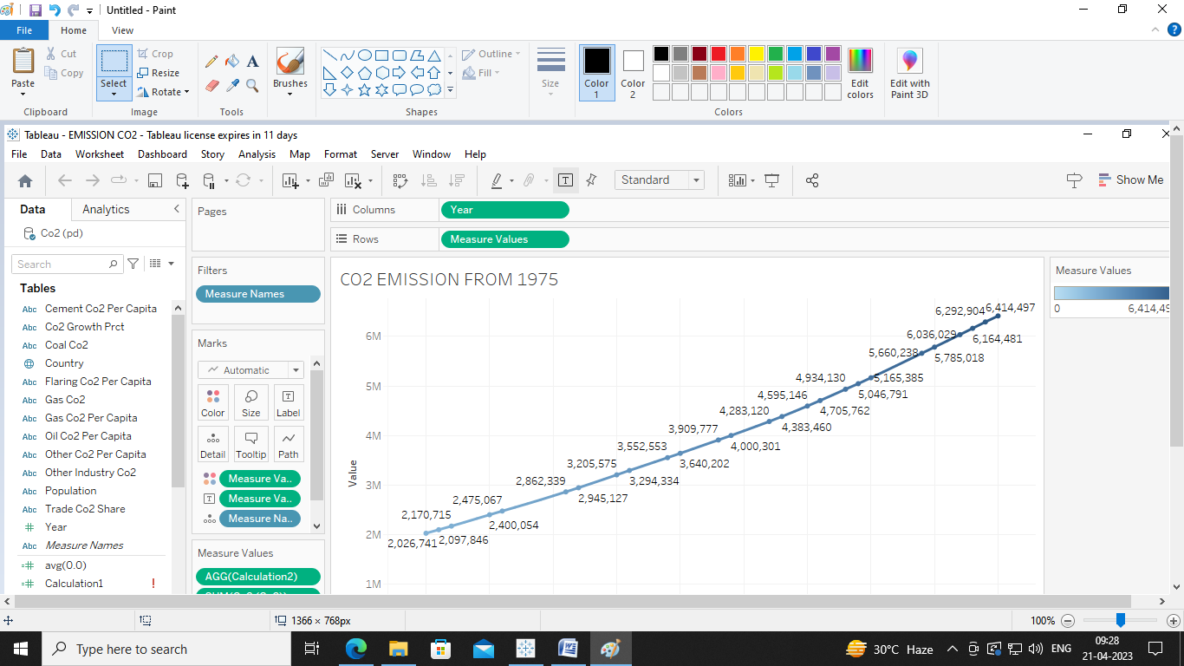

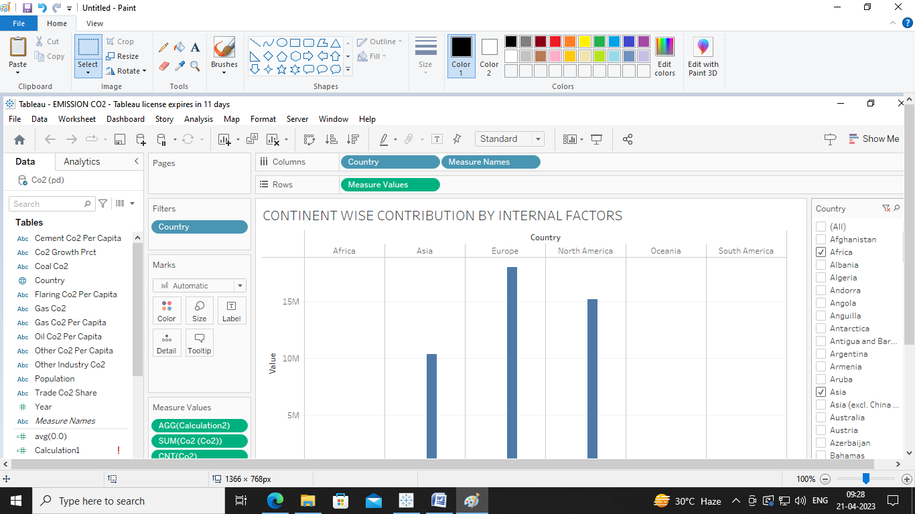

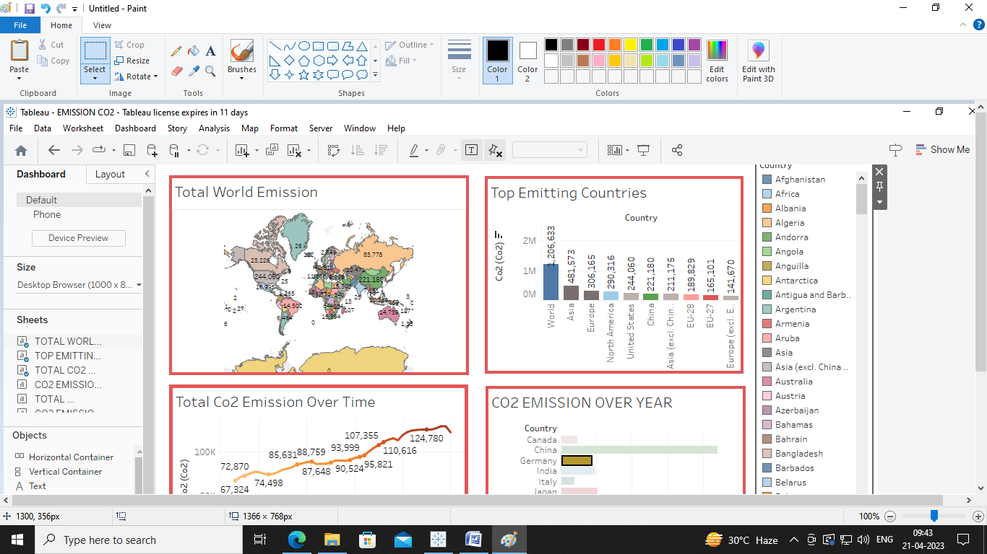

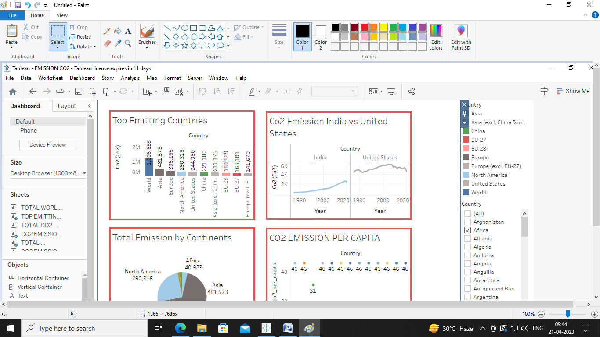

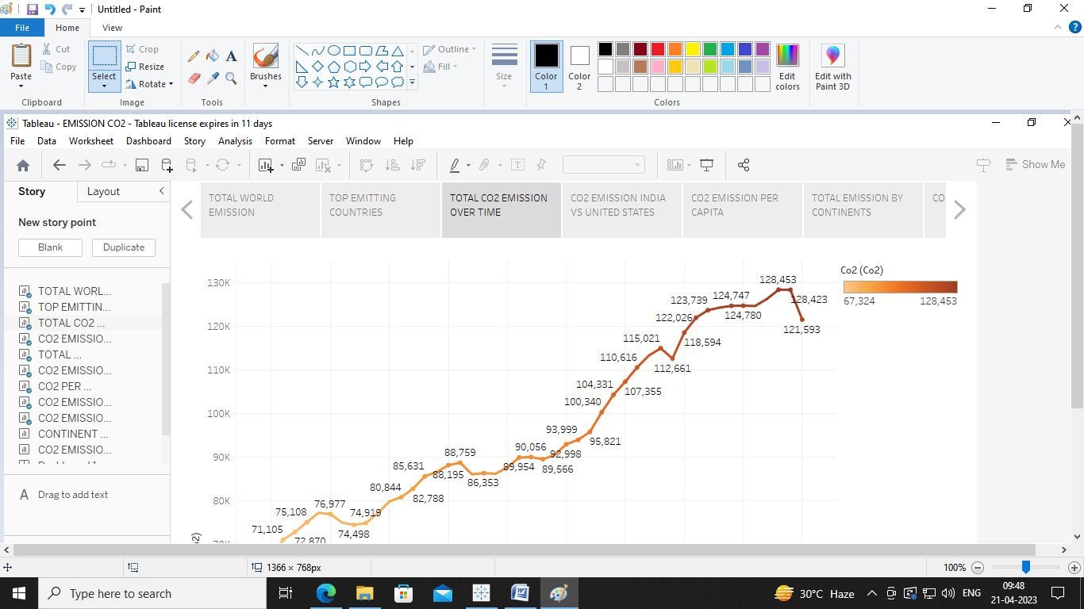

**4. trailhead profile**

**Team Lead-** [**https://trailblazer.me/id/akraj75**](https://trailblazer.me/id/akraj75)

**TEAM MEMBER1-** [**https://trailblazer.me/id/anisha68**](https://trailblazer.me/id/anisha68)

**TEAM MEMBER2-**[**https://trailblazer.me/id/arosm9**](https://trailblazer.me/id/arosm9)

**TEAM MEMBER3-**[**https://trialblazer.me/id/arusr2**](https://trialblazer.me/id/arusr2)

**Team member4-**[**https://trialblazer.me/id/vijiv8**](https://trialblazer.me/id/vijiv8)

**TABLEAU PUBLIC DASHBOARD LINK-**

[**https://public.tableau.com/views/EMISSIONCO2_16818144546420/Dashboard1?:language=en-US&:display_count=n&:origin=viz_share_link**](https://public.tableau.com/views/EMISSIONCO2_16818144546420/Dashboard1?:language=en-US&:display_count=n&:origin=viz_share_link)

**TABLEAU PUBLIC STORY LINK-**

<https://public.tableau.com/views/EMISSIONCO2story/Story1?:language=en-US&:display_count=n&:origin=viz_share_link>

**5. ADVANTAGES AND DISADVANTAGES OF CARBON DI OXIDE**

**ADVANTAGES:**

## Food Processing

## **The global food industry depends on CO2 for short-term and long-term refrigeration of food products.** CO2 not only serves as a refrigerant, but it also acts as an anaerobic agent, which boosts the chemical’s value for food preservation purposes. Many food processors use CO2 for individual quick freeze, grinding and commercial packaging.

## Plant Growth

## The Endowment for Medical Research cites university studies that show increasing the level of CO2 to 550 parts per million (ppm) speeds up plant growth as much as 40 percent in a controlled greenhouse environment. The CO2 levels in the average greenhouse, with a closed ventilation system, decreases to 150 ppm to 200 ppm. **During the summer, opening the ventilation system allows fresh air into the greenhouse, which increases the CO2 level.** However, during the winter, in northern regions, the circulation of cold outside air into heated greenhouses could kill plants.

## DISADVANTAGES:

## Greenhouse Gas Emissions

## Greenhouse gases, such as nitrous oxide, methane and CO2, affect the heat flow to and from the earth’s atmosphere. Some scientists argue the huge increase in CO2 and other greenhouse gases released into the atmosphere will cause the average worldwide temperature to increase anywhere from 2 to 11.5 degrees Fahrenheit by 2100, according to the Environmental Defense Fund. This rise could have negative consequences, including severe droughts and powerful storms.

## Toxicity

High indoor levels of CO2 could lead to severe health effects, even death. According to "Current Science" magazine, studies have demonstrated that people can sense a decline in air quality when CO2 levels reach 600 ppm. When CO2 reaches or exceeds this level, then individuals usually begin to demonstrate signs of CO2 poisoning, including a rapid pulse rate, loss of hearing, breathing difficulties and sweating and fatigue.

**5. APPLICATIONS**

**USES oF CARBONDIOXIDE:**

## Industrial Applications

## Carbon dioxide gas is used in industries to produce chemicals and as feedstock. According to “IPCC Special Report on Carbon Dioxide Capture and Storage,” carbon dioxide gas is involved in the production of refrigeration systems, welding systems, water treatment processes (to stabilize the pH of water) and carbonated beverages. It is also used in the metals industry to enhance the hardness of casting molds and as a soldering agent. Carbon dioxide is found in various fire extinguishers and prevents oxygen from further fueling a fire. Carbon dioxide-based fire extinguishers effectively manage electrical fires and those caused by solvents, fuels and oils.

## Chemical and Pharmaceutical Applications

Carbon dioxide gas is used to make urea (used as a fertilizer and in automobile systems and medicine), methanol, inorganic and organic carbonates, polyurethanes and sodium salicylate. Carbon dioxide is combined with epoxides to create plastics and polymers. It is used for water treatment; to keep food cool (as dry ice); and to cool, pressurize and purge equipment.

## Electronic Applications

Carbon dioxide gas is used in the electronics industry for circuit board assembly, to clean surfaces and in the manufacture of semiconductor devices.

## Oil Industry

Carbon dioxide gas is used in enhanced oil recovery (EOR). EOR is a class of techniques for increasing the quantity of extracted crude oil from oil fields. Carbon dioxide is injected under high pressure into an oil reservoir, which pushes the oil through pipes and up to the surface of the ground. Carbon dioxide gas injection aids oil recovery and reduces the viscosity of recovered oil.

**Conclusion :**

It is clear from the material presented in this report that the modern rise in the air's CO2 content is providing a tremendous economic benefit to global crop production. As Sylvan Wittwer, the father of agricultural research on this topic, so eloquently put it nearly two decades ago:

"The rising level of atmospheric CO2 could be the one global natural resource that is progressively increasing food production and total biological output, in a world of otherwise diminishing natural resources of land, water, energy, minerals, and fertilizer. It is a means of inadvertently increasing the productivity of farming systems and other photosynthetically active ecosystems. The effects know no boundaries and both developing and developed countries are, and will be, sharing equally," for "the rising level of atmospheric CO2 is a universally free premium, gaining in magnitude with time, on which we all can reckon for the foreseeable future" (Wittwer, 1995).

The relationship described above by Wittwer is illustrated below in Figure 8, where data pertaining to atmospheric CO2 emissions, food production, and human population are plotted. Standardized to a value of unity in 1961, each of these datasets has experienced rapid and interlinked growth over the past five decades. Rising global population has led to rising CO2 emissions and rising CO2 emissions have benefited food production.

The very real positive externality of inadvertent atmospheric CO2 enrichment must be considered in all studies examining the SCC; and its observationally-deduced effects must be given premier weighting over the speculative negative externalities presumed to occur in computer model projections of global warming. Until that time, little if any weight should be placed on current SCC calculations.

**7. future scope**

In the [Annual Energy Outlook2022](https://www.eia.gov/outlooks/aeo/)(AEO2022) Reference case, which assumes no changes to current laws or regulations, the U.S. Energy Information Administration (EIA) projects that U.S. energy-related carbon dioxide (CO**2**) emissions will fall to 4.5 billion metric tons in 2037, or 6% below the energy-related CO**2** emissions in 2021, before rising to 4.7 billion metric tons in 2050, or 2% below 2021 levels. Projected emissions decline from 2022 to 2037 primarily as a result of decreasing carbon intensity (CO**2** per unit of energy consumed) in the electric power sector. The rise in emissions from 2037 to 2050 is primarily due to increasing consumption. In the AEO2022 Reference case, U.S. energy consumption grows from 2021 through 2050 because of population growth of 0.4% per year and real economic growth of 2.2% per year. Over the projection period, increasing CO**2** emissions from natural gas and petroleum consumption growth will offset declines in CO**2** emissions from coal consumption.